DAE Systems
Military vehicles fan applications
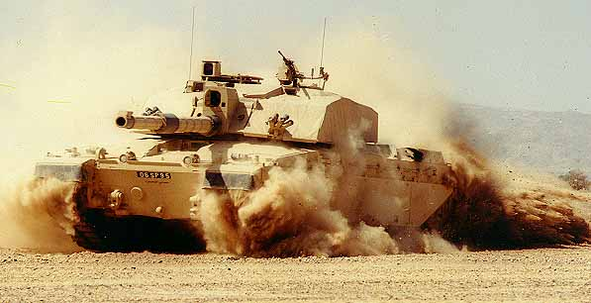
The movement of air inside a Military Vehicle takes many guises but is essential for the operation, safety and comfort of both personnel and equipment.

Faced by the most challenging applications and severe operating conditions, the expertise within DAE Systems is a sure guarantee of an optimum solution to any Air Movement problem.

Typical applications in which DAE Systems air moving systems are implemented include:

Gun smoke extract – used to exhaust toxic fumes from the vicinity of machine gun and cannon breaches. These fans can be produced in single, twin or variable speed versions, matching the severity of the pollution, or doubling as vent fans on silent watch.

Ventilation – many vehicles, principally armoured personnel carriers, command and communication vehicles, ambulances, missile carrying vehicles and armoured cars, use brushless DC ventilation fans.
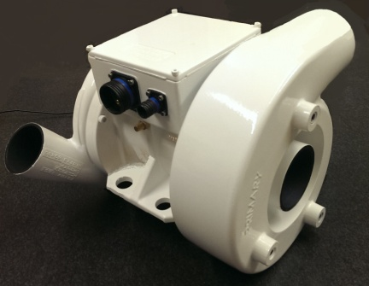
CBRN Filtration (Dust Blowers) – used to provide the main flow air through a CBRN filter at the same time providing a scavenge flow to particle separators, removing sand and dust. Optimising two fans on the same shaft of a single motor, up to 65Amp DC power capability. Providing crucially filtered air to the crew in a CBRN environment.

Scavenge Fans – used when a vehicle is in a heavy dust environment, a fan in conjunction with a cyclonic filter, ensures that dust and sand are excluded from engine combustion air and vehicle filter systems. Utilising specialist materials and processes to withstand the high erosion environment.
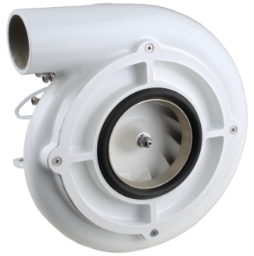
Equipment cooling – with the ever increasing electronic equipment within a vehicle the heat load increases, with high temperatures and solar energy adding to the problem, electronics are reaching their upper operating temperatures. Forced air cooling and spot cooling is provided within and without
individual electronic equipments.
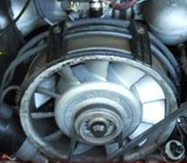
Engine Cooling Fans – today’s power pack designers face an ever increasing demand for cooling air through a variety of high density radiators, including engine radiators, charge coolers, transmission and oil coolers all competing for space in the engine bay. Engine cooling fans can be driven directly by shaft or belt or hydraulic drives.
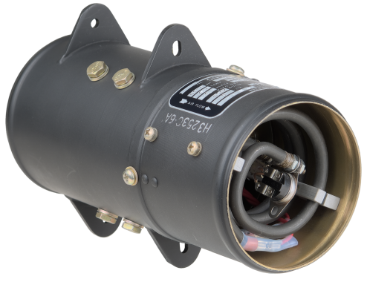
Crew Heaters – used in main battle tanks, light tanks, armoured personnel carriers, these units are designed to raise the ambient temperature in a vehicle sufficient to protect the crew from extreme cold.

DAE Systems can offer these units with controllers and harness especially suitable for retrofitting vehicles for cold climates. A fan is coupled to a fixed resistance heater providing a warm air stream for powers up to 3kw.

Fan Types

For all applications the fans are of Axial, Centrifugal or Mixed Flow configuration, where the specified duty point will dictate the type of fan geometry chosen. Fan selection is always going to be a trade off between Performance, Size, Weight, Noise, Efficiency, Cost, and Reliability, but a simple generalisation as follows:
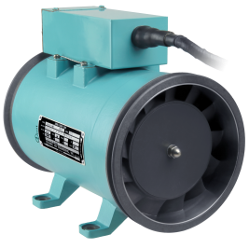

Axial Fans for: Flow, best power to weight/size ratio
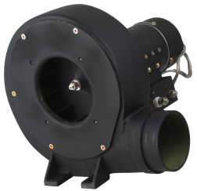

Centrifugal Fans for: Pressure, variable resistance applications, robustness
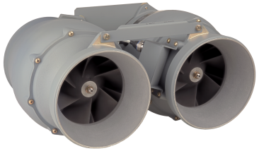

Mixed Flow Fans for: Combining Flow and Pressure, Low noise, versatile, variable resistance

The most common drive for fans is an electric motor, but all the fan types can be arranged to be driven by a direct shaft or belt driven or with a hydraulic motor. DAE Systems has experience with the following:
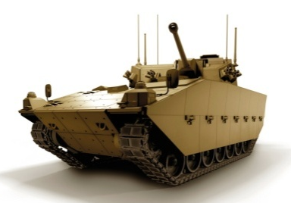
- AC supply 400Hz, 60Hz, 50Hz
- AC supply Variable frequency
- DC supply 24 - 28V – Brushed and Brushless motors
- DC supply 270V – Brushless
- Hydraulic Drive
- Mechanical Drive

Many vehicles in the security industry only have 12 vdc available, also some have highly specialised DC power supplies, consequently DAE Systems produce motors over the range 12vdc to 540vdc.

For further information on choosing the right fan for your requirement, please refer to our website, or contact us.

